**FRAME**

# Objective

⇨ Structure the car and ensure the position and the sustainability of other systems ⇨ Ensure the pilot security

# Conception steps:

Step 1: The rules imposed few extremal dimensions as the size of the cockpit, the front of the frame and also the position of tubes on the side impact.

Step 2: Suspension preference-based conception.

Step 3: Make the integration of the engine easier thanks to removable bracings.

Step 4: Improve the pilot position making it more comfortable. Minimization of the front hoop in order to improve the pilot visibility.

# Important values

* Stiffness

O Target: 1000-1500 Nm/deg

O Simulation: 1114 Nm/deg

O Measure: 1205 Nm/deg

* Weight with paint and equipment

O Target: 39-42 kg

O Simulation: 40.6 kg

O Measure: 41 kg

* Steel: 25CrMo4 (AISI4130)
* Yield strength: 7.108 N/m²

# Simulation

## Hypothesis

* Elastic behaviour
* Small displacement
* No dynamic phenomenon
* Welding beams as resistant as tubes

# Results

NB: Except for torsion, all load cases come from MécaMaster

Figure 1: Torsion

Figure 2a: Acceleration 0.77g

Figure 2b: Acceleration 0.77g

Figure 3a: Braking 2g

Figure 3b: Braking 2g

Figure 4a: Bump 3g

Figure 4b: Bump 3g

Figure 5a: Left turn 2g

Figure 5b: Left turn 2g

Figure 6a: Left turn 1g + braking 1g

Figure 6b: Left turn 1g + braking 1g

# Stiffness measure experiment

# 

Figure 7: Stiffness measurement on the frame

Measure performed in two times:

* Apply a torque to the front and the cockpit of the frame, blocking the back
* Apply a torque at the back, blocking the front

The difference between the simulated and the measured values may come from the boundaries conditions that are not exactly the same.

Ecrire nos résultats des tests en torsion

# Equipment positioning

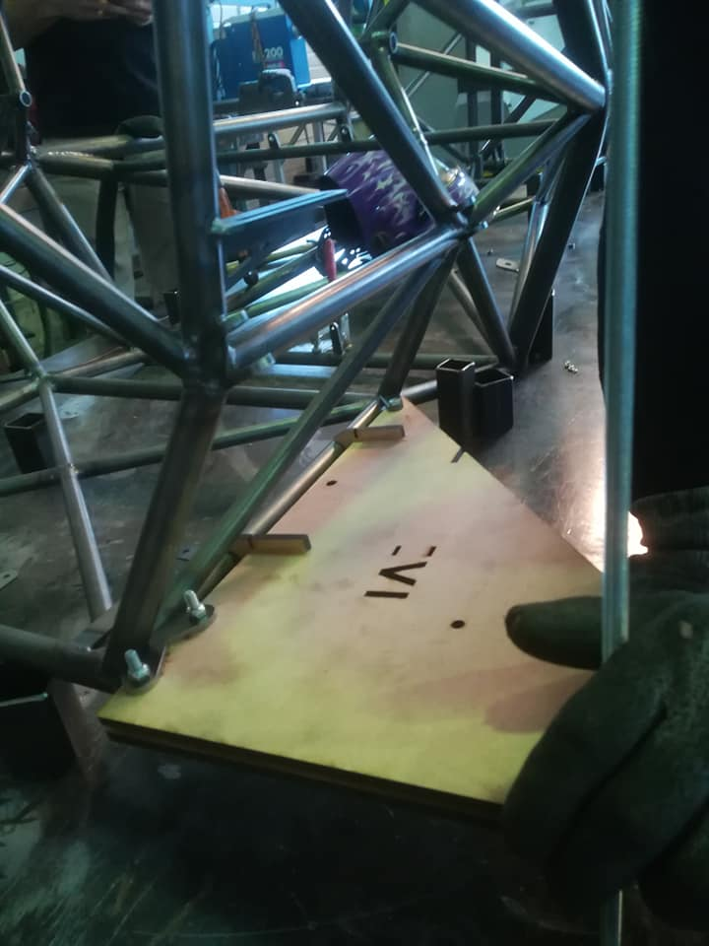

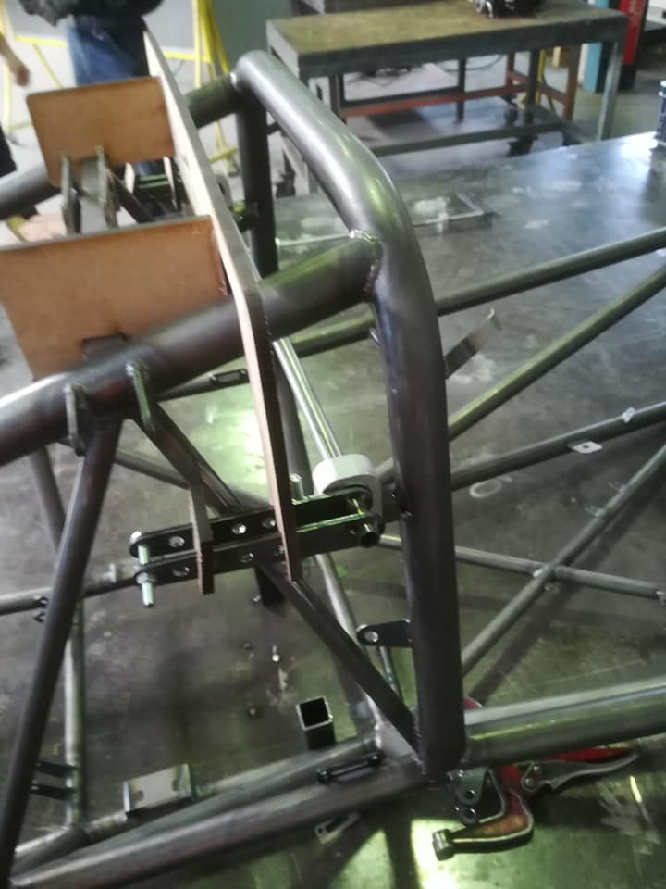 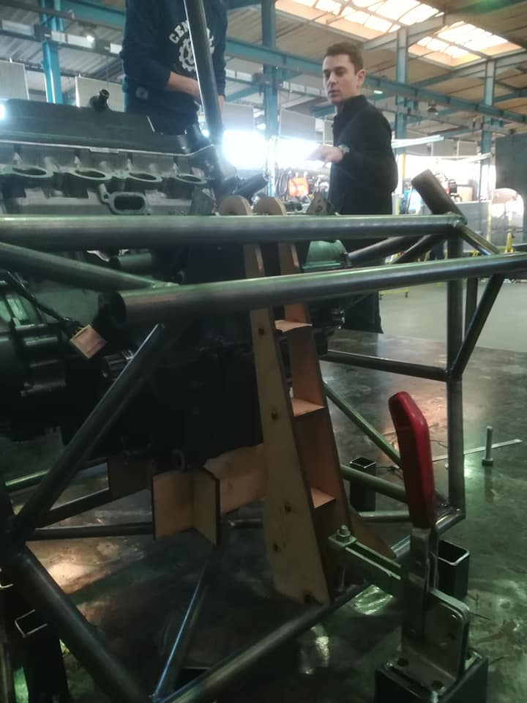 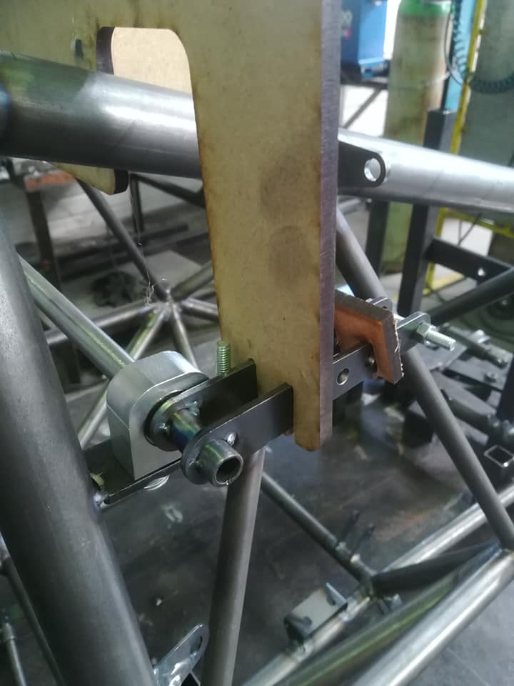

Figure 8: Use of templates to precisely position equipments during welding

# Pilot position

Figure 10: Human model in CAD model to help designing the chassis

# Tractive tests results

Résumé tests traction A2M

Photo des échantillons ?

# Appendix

## Stiffness model (coefficient 𝛼)

Frame: 3 series torsion springs

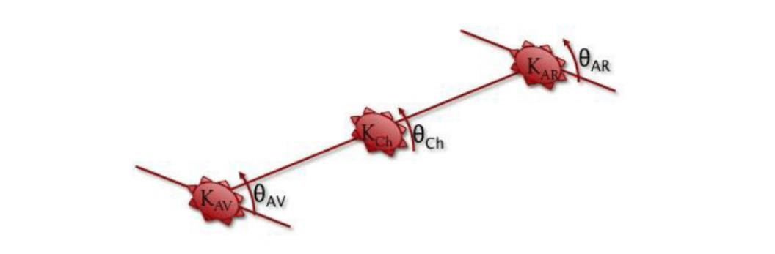

Figure 9: Definition of the model

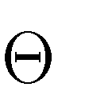Where K=stiffness and =angle. We also define 𝐾𝑇 and 𝜃𝑇 respectively the stiffness and the angle of the car.

In order to simplify the equations, we suppose 𝐾𝐴𝑉 = 𝐾𝐴𝑅; 𝛼. 𝐾𝐴𝑉 = 𝐾𝑇 𝑎𝑛𝑑 𝜃𝐴𝑉 = 𝜃𝐴𝑅. It gives us the following equations:

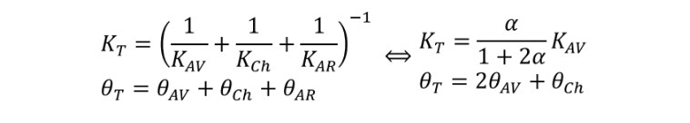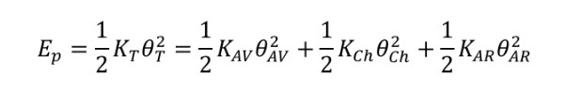

Finally,

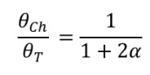

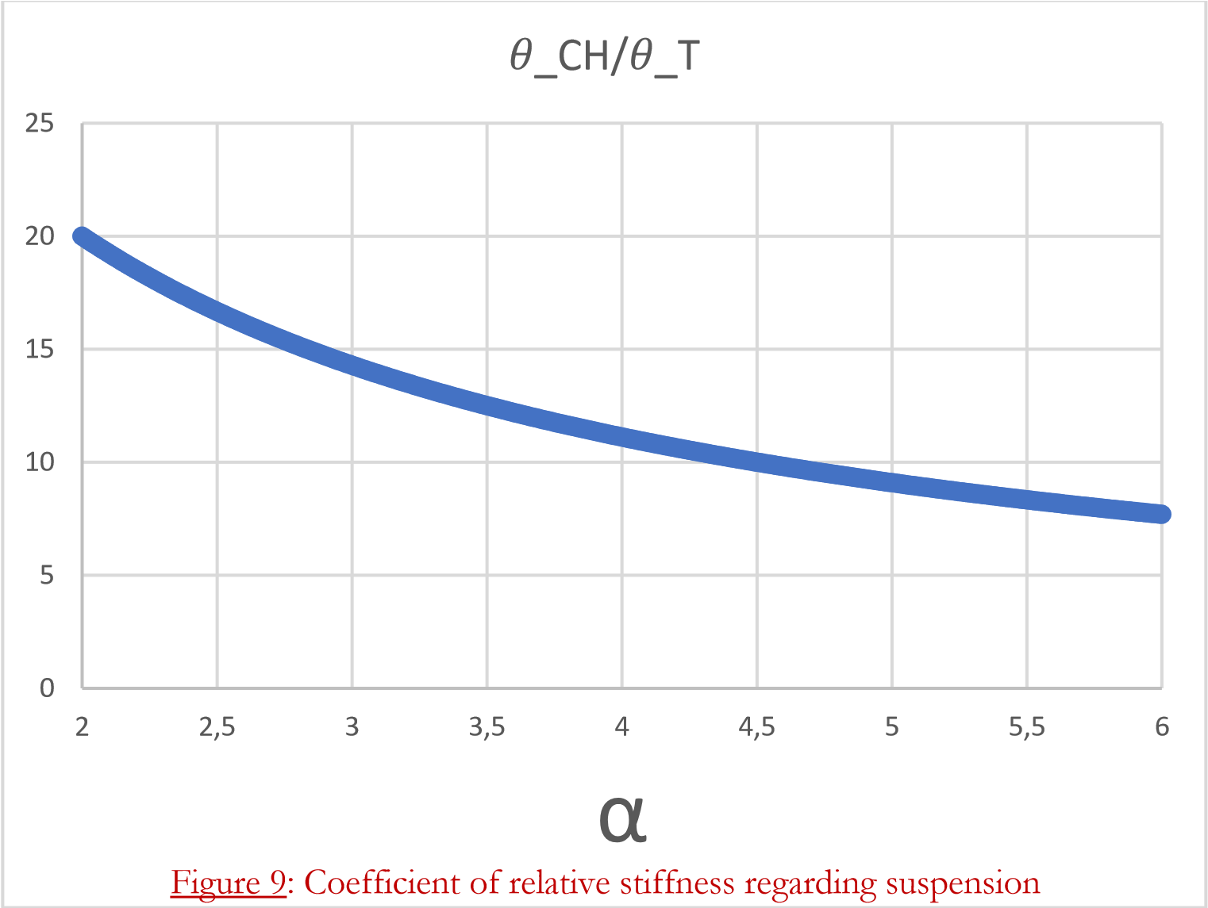

If we want to keep 𝜃𝐶𝐻/𝜃𝑇 between 10% and 15%, we have to take α between 3 and 5.